**Team:** Mariah, Jing, Baskaran, Ricky

**Project Proposal:** What goes into a good Ted Talk? Our project will look into many factors to evaluate what elements make some of these videos extremely popular. TedTalk’s website gives us detailed information that we can use to better understand their platform and its many viewers.

**Data Source**: Ted talks data – CSV

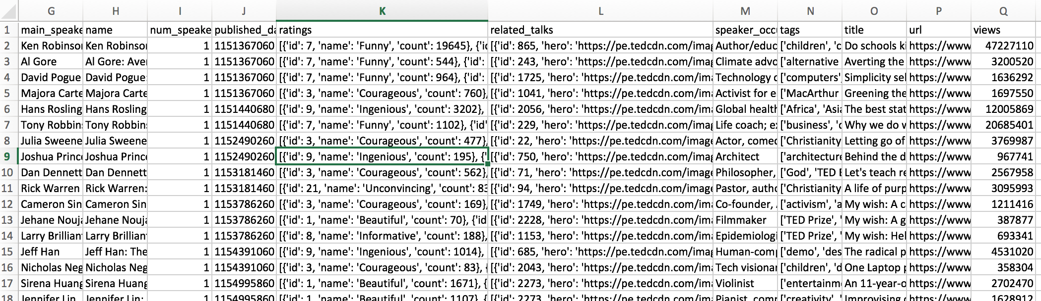

**Database:** MongoDB

**Examples of data to analyze:**

-Most popular Talks by category, views, comments, etc.

-Do certain videos get popular after certain events? (i.e: recession in ‘08)

-Categories: education, tech, health, love

-Look at rating information to see what factors contribute to the success of a video

**Repository:** https://github.com/jgdataquest/TedTalk

**New JS Library:** jQuery

**Responsibilities Week 1:**

**Baskaran:** Create API and deploy on Heroku

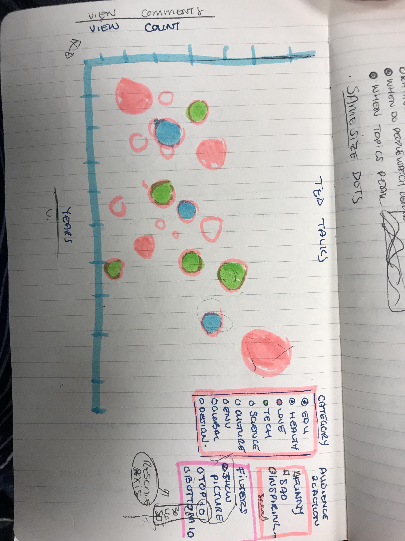

**Sketch of scatterplot being created:**

**Inspiration:**

